Exp no:6 RAD MODEL :

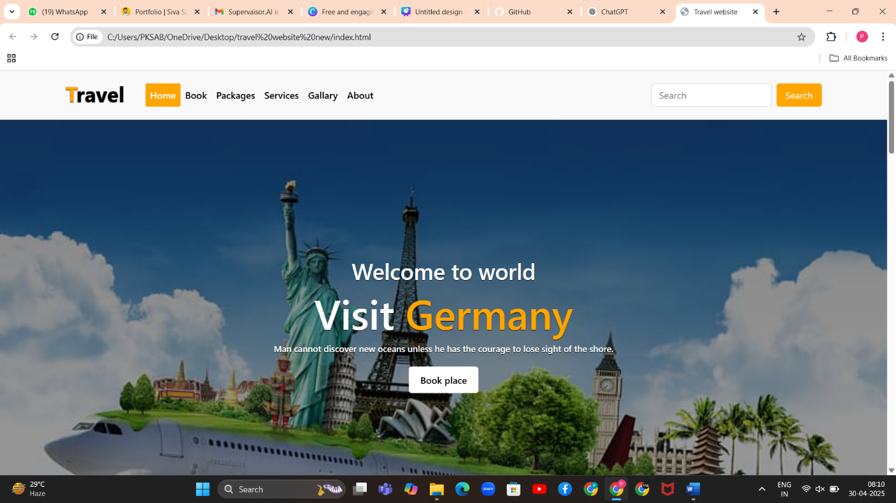

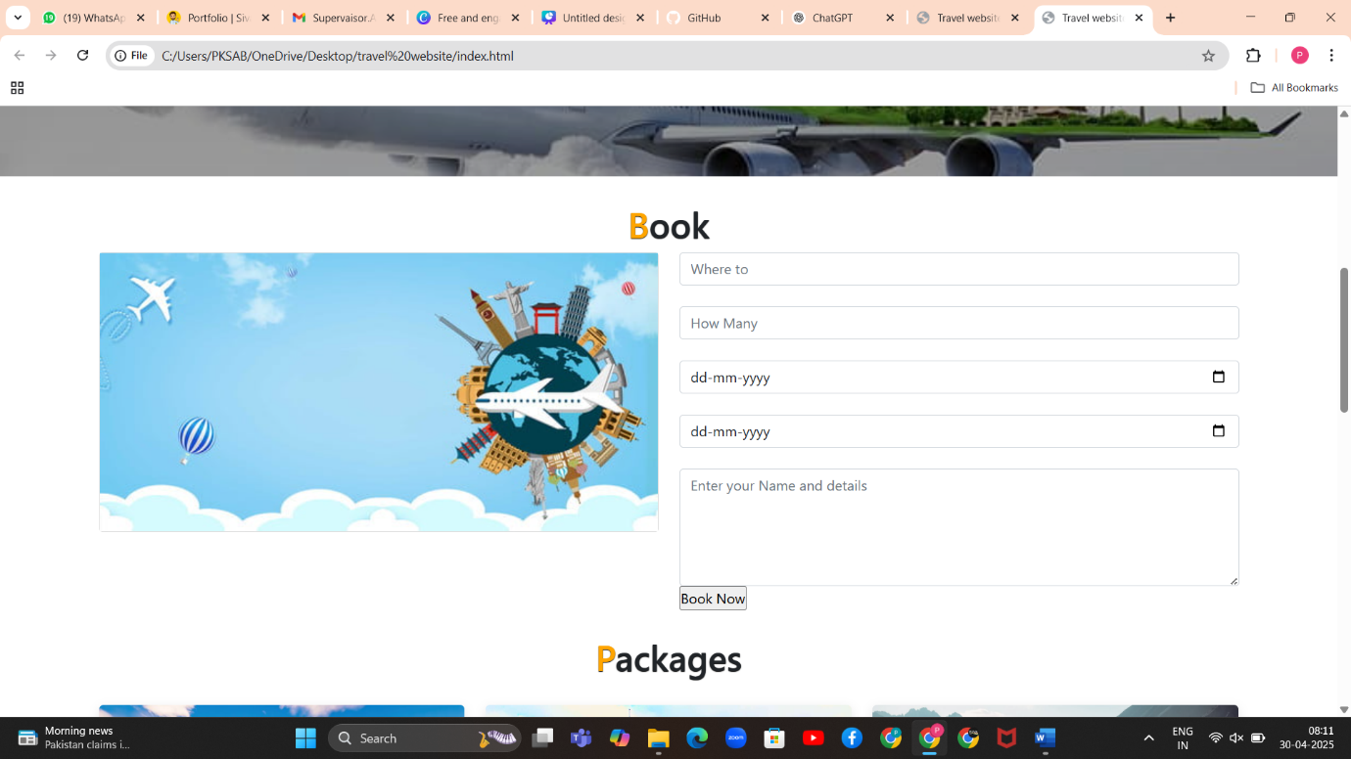

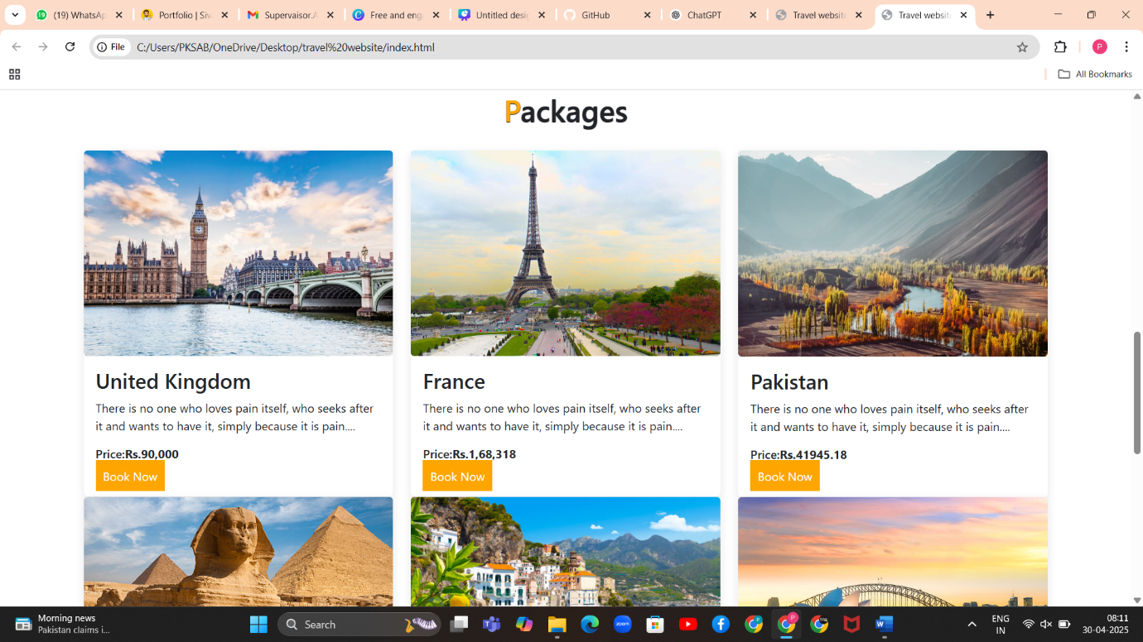

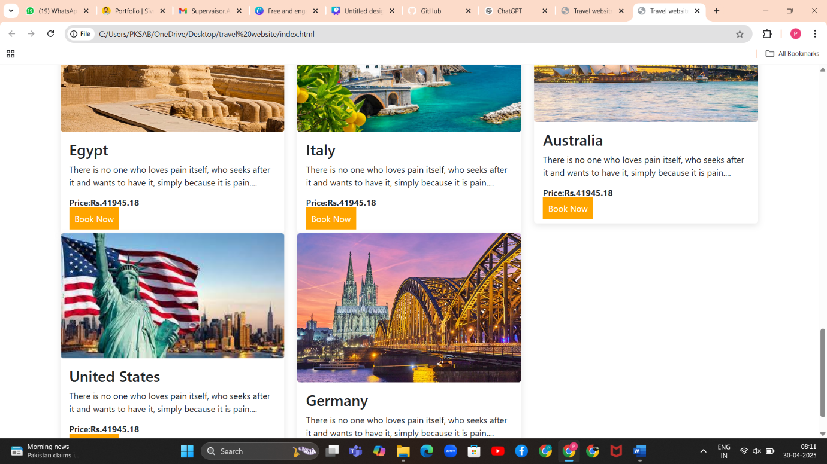

Initially, the travel website was built with basic functionality and limited user interface elements. It lacked a visually appealing design and did not offer any specific travel-related services like flight bookings, hotel reservations, or travel insurance. The navigation was minimal, and there were no dynamic components or clear call-to-actions, making the user experience underwhelming and the website less engaging for visitors.

To address these limitations and enhance the overall quality and functionality of the platform, I adopted the **Rapid Application Development (RAD)** model. This approach allowed me to work iteratively and collaboratively, focusing on quick prototyping, continuous user feedback, and rapid refinement of the system.

**RAD Model Application & Updates:**

1. **Requirements Planning**  
   I gathered feedback from potential users and peers to identify essential features such as service listings, better navigation, and a modern UI. The primary goals were to improve usability and offer key travel services that would make the site more functional and market-ready.
2. **User Design Phase**  
   Using tools like Figma and basic HTML/CSS prototyping, I designed wireframes for the homepage, services section, and booking pages. These designs focused on responsiveness, ease of navigation, and clarity. Prototypes were shared with users for feedback, and several iterations were made to improve layout, color scheme, and content flow.
3. **Construction Phase**  
   I updated the website using modern web technologies like React for a dynamic front-end and styled components for consistent UI. I implemented the following services:
   * **Flight Booking**
   * **Hotel Reservation**
   * **Car Rentals**
   * **Travel Insurance**
   * **Customized Tour Packages**  
     The backend was extended using Node.js and MongoDB to handle data for these services, and new API routes were created to support search and booking functionality.
4. **Cutover Phase**  
   The updated website was tested for functionality, responsiveness, and usability. After resolving bugs and ensuring that all service features were working smoothly, the site was deployed using a cloud platform (e.g., Netlify or Vercel). User testing confirmed improved satisfaction and a more professional feel.

**Outcome:**

By following the RAD model, I was able to transform a static, limited website into a fully functional travel portal with essential services and a much-improved user interface. The iterative process allowed quick adaptation to feedback, resulting in a platform that is more user-centric and ready for real-world use.

